# UNLOCKING INSIGHTS INTO THE GLOBAL AIR TRANSPORTATION NETWORK WITH TABLEAU

# 1.INTRODUCTION:

# 1.1 Overview

# The global air transportation network is a complex and dynamic web, connecting people, goods, and ideas across the world. It is an industry where safety, efficiency, and innovation are paramount. Unlocking insights within this intricate network is essential for ensuring smooth operations, improving the passenger experience, and making informed decisions. This topic explores the integration of Tableau, a powerful data visualization and analytics tool, into the aviation sector.

# 1.2 Purpose

# Safety is of paramount importance in aviation. By harnessing the power of data and Tableau’s tools, this topic aims to showcase how airlines and aviation authorities can gain insights that contribute to safer air travel. Passengers are at the heart of the aviation industry. In a competitive marketplace, airlines and aviation companies are continually seeking ways to gain an edge.

# 2.PROBLEM DEFINITION & DESIGN THINKING

# EMPATHY MAP

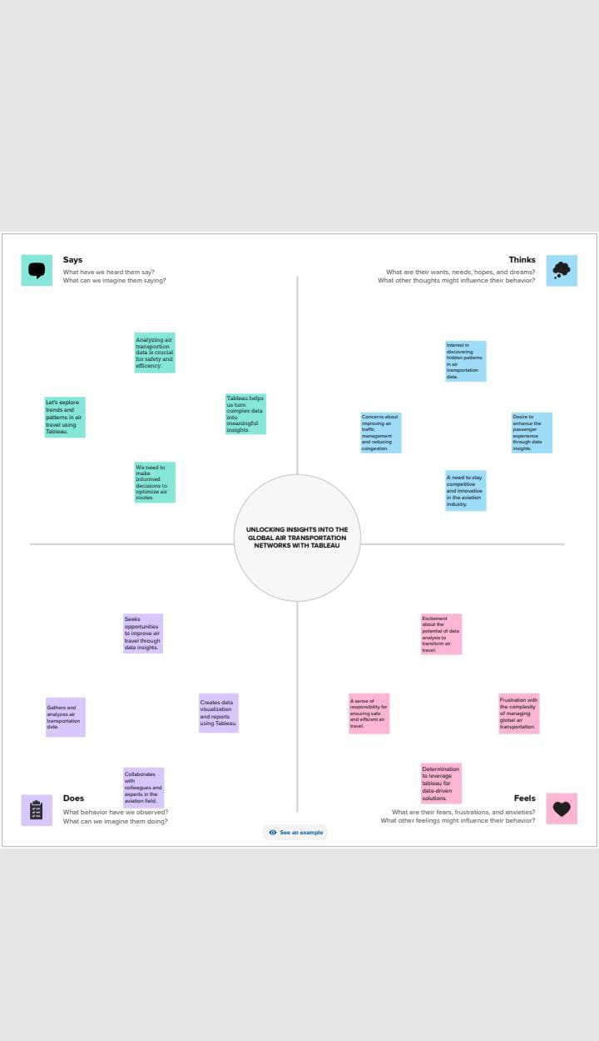



# 3. ACTIVITY AND SCREENSHORT

# 1. Analyzing flight data for operational optimization

# 2. Passenger experience enhancement

# 3. Market trends and competitive analysis

# 4. Top 10 countries with air transportation

# 5. Airport efficiency analysis

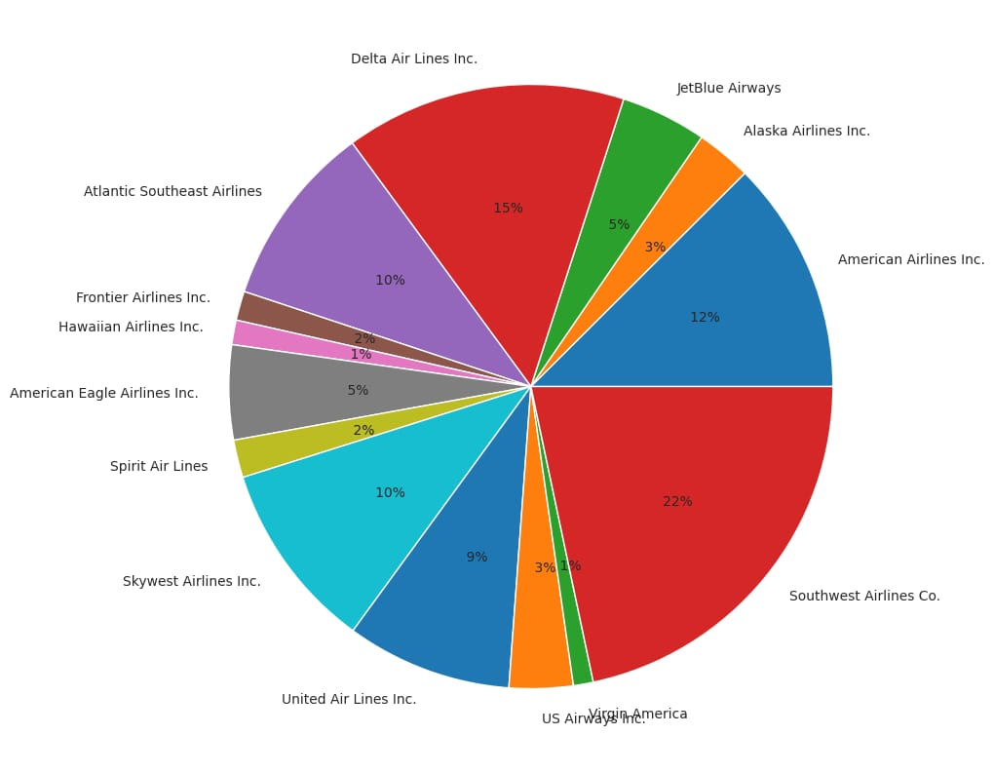

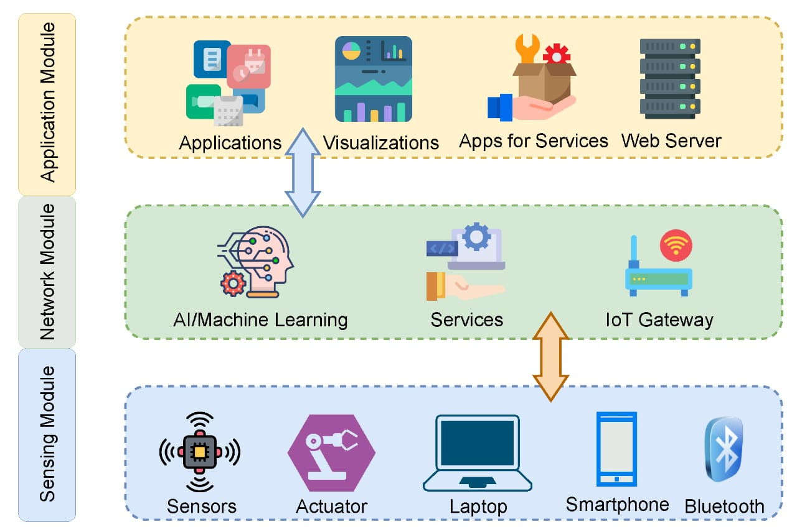

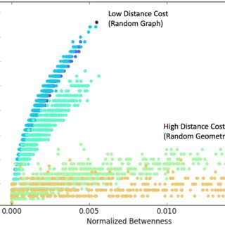

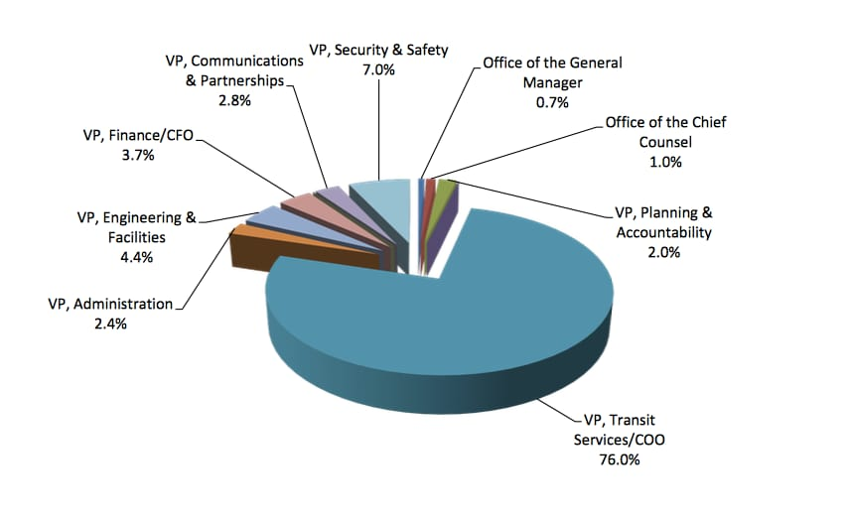

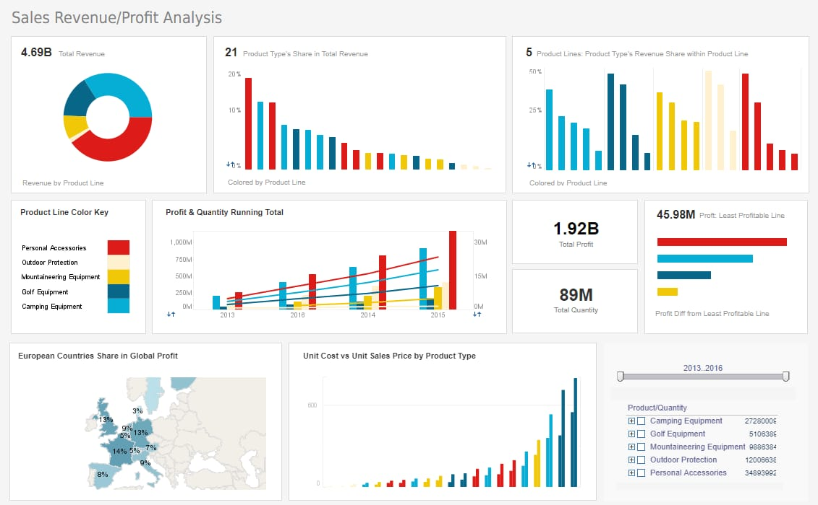

# WhatsApp Image 2023-10-13 at 1.08.29 AM (4).jpeg

# 4. ADVANTAGE AND DISADVANTAGE

# ADVANTAGES

# Powerful data visualization

# Real-time data analysis

# Fastest mode of transport

# Air travel is str ategically significant

# Useful during natural disasters

# DISADVANTAGE

# High operational costs

# Air transport accidents are usually fatal

# Huge initial investments

# Difficult to carry very large cargo

# Affected by bad weather

# 5. APPLICATIONS

# Airlines and aviation companies can use tableau to monitor real-time flight operations, track aircraft movements, and analyze operational data.

# Tableau can be employed to analyze historical flight data, identify trends in passenger demand, and optimize flight routes.

# The tool is valuable for safety analysis, enabling aviation professionals to visualize safety-related data, track incidents and identify areas for improvement.

# 6. CONCLUSION

# In conclusion, harnessing the power of tableau in the context of the global air transportation network holds tremendous potential for revolutionizing the aviation industry.

# The ability to unlock insights from vast and complex data sources has far-reaching implications, impacting safety, efficiency, passenger experience, and competitiveness.

# 7. FUTURE SCOPE

# Advanced predictive analytics: Tableau’s capabilities are expected to evolve, allowing for more advanced predictive analytics.

# Enhanced real-Time monitoring: The aviation industry thrives on real-time data. Tableau is likely to provide even more advanced real-time monitoring features, helping airlines and authorities respond swiftly to changing conditions, from weather disruptions to security concerns

# 

# 